1. Write a query to get the ten most expensive Products (name and unit price).

SELECT product_name, unit_price

FROM products

ORDER BY unit_price

DESC LIMIT 10

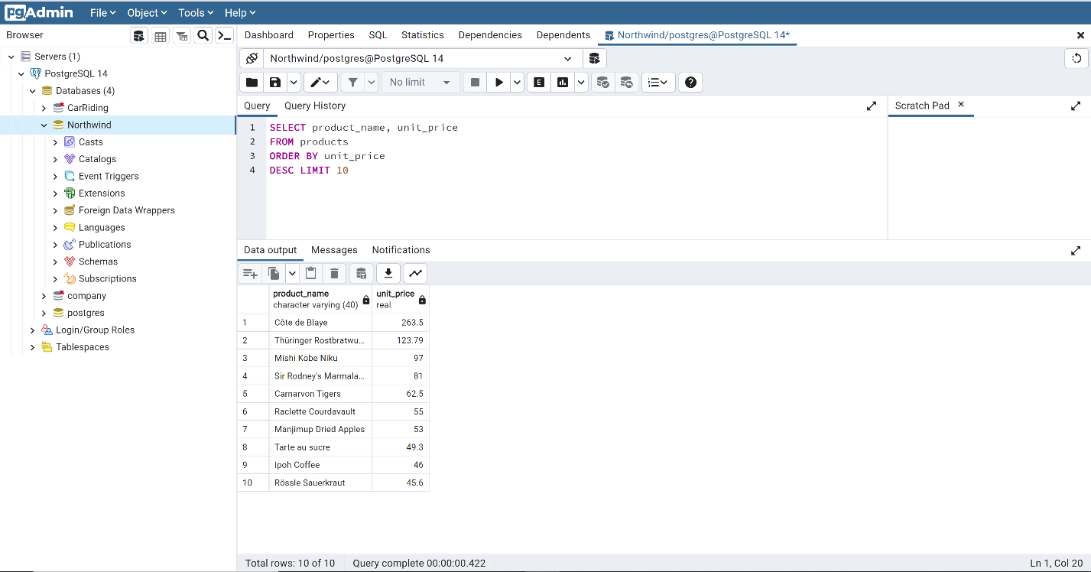

2. Write a query to get Product list (id, name, unit price) where products cost between $15 and $25

SELECT product_name, product_id, unit_price

FROM products

WHERE (unit_price BETWEEN 15 AND 25 )

ORDER BY product_name

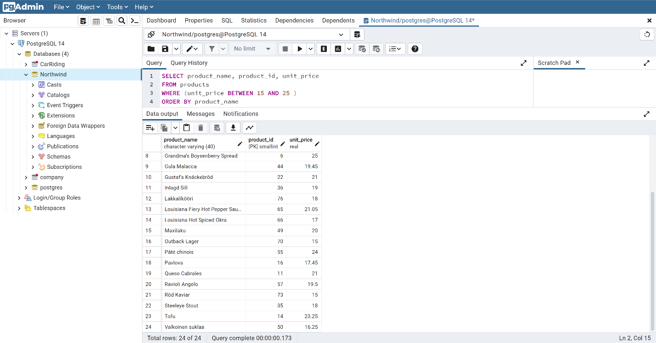

3. For each order, calculate a subtotal for each Order (identified by OrderID). This is a simple query using GROUP BY to aggregate data for each order. The formula to calculate the subtotal for each order is UnitPrice * Quantity * (1 - Discount).

SELECT order_id , (unit_price * quantity * (1 -discount)) AS subtotal

FROM order_details

GROUP BY order_id, subtotal

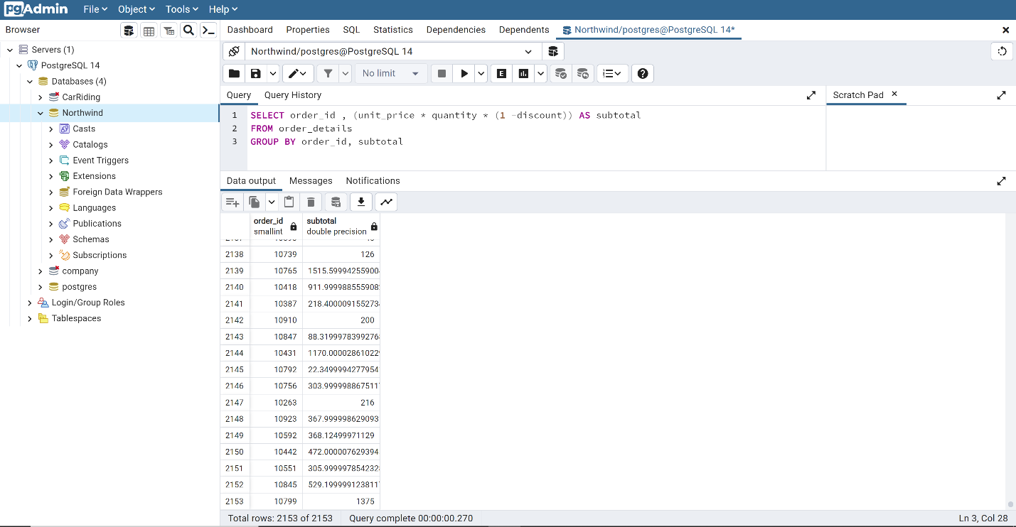

4. For each employee, get their sales amount, broken down by country name. We need to retrieve the country, last name, first name, shipped date, order id and the subtotal as sales_amount (using this formula: Unit_Price * Quantity * (1 - Discount)).

SELECT e.country , e.last_name , e.first_name , o.order_id ,

(d.unit_price * d.quantity * (1 - d.discount) ) AS sales_amount

FROM employees e

JOIN orders o ON e.employee_id = o.employee_id

JOIN order_details d ON o.order_id = d.order_id

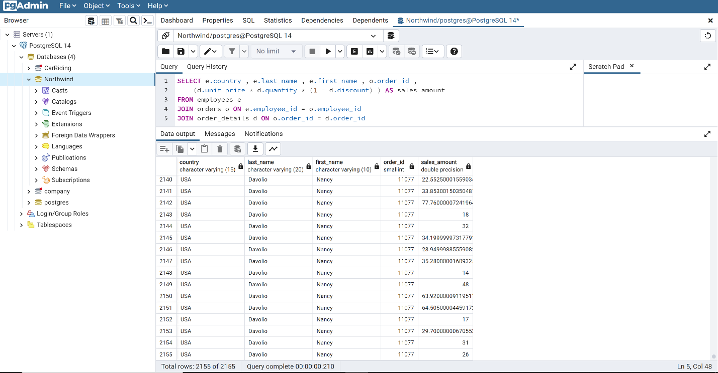

5. List the company name, contact name from Customers and Suppliers by City. In the result of the query you need to specify who are the customers and who are the suppliers.

SELECT c.company_name AS customer, c.contact_name AS customer_contact_name, c.city AS customer_city,

s.company_name AS supplier, s.contact_name AS supplier_contact_name, s.city AS supplier_city

FROM customers c

JOIN orders o ON c.customer_id = o.customer_id

JOIN order_details d ON o.order_id = d.order_id

JOIN products p ON d.product_id = p.product_id

JOIN suppliers s ON p.supplier_id = s.supplier_id

ORDER BY c.city

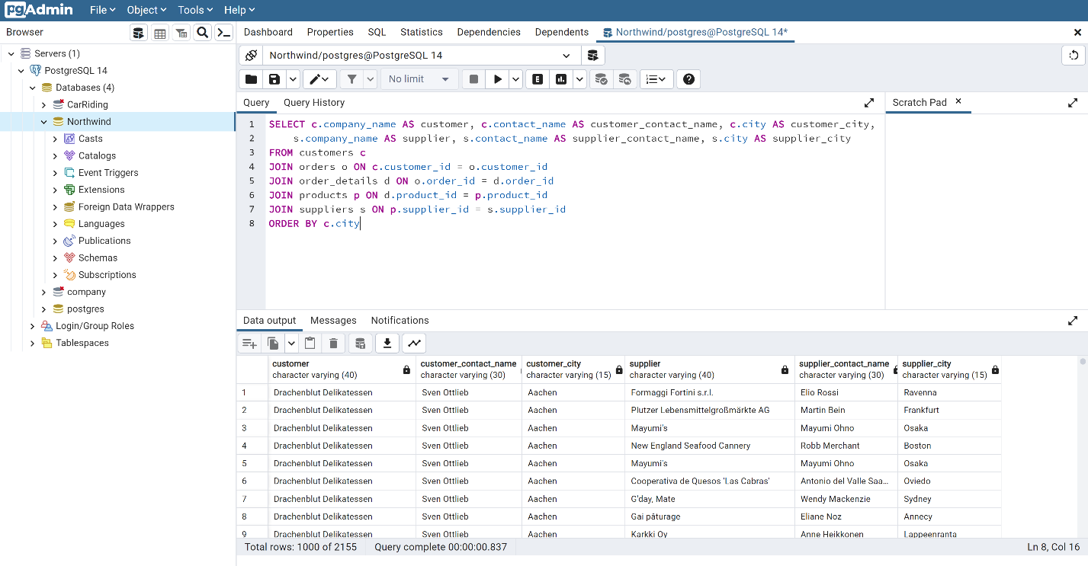

6. List the product name and unit price for products above the average price

SELECT product_name, unit_price

FROM Products

WHERE unit_price > (SELECT avg(unit_price) FROM Products)

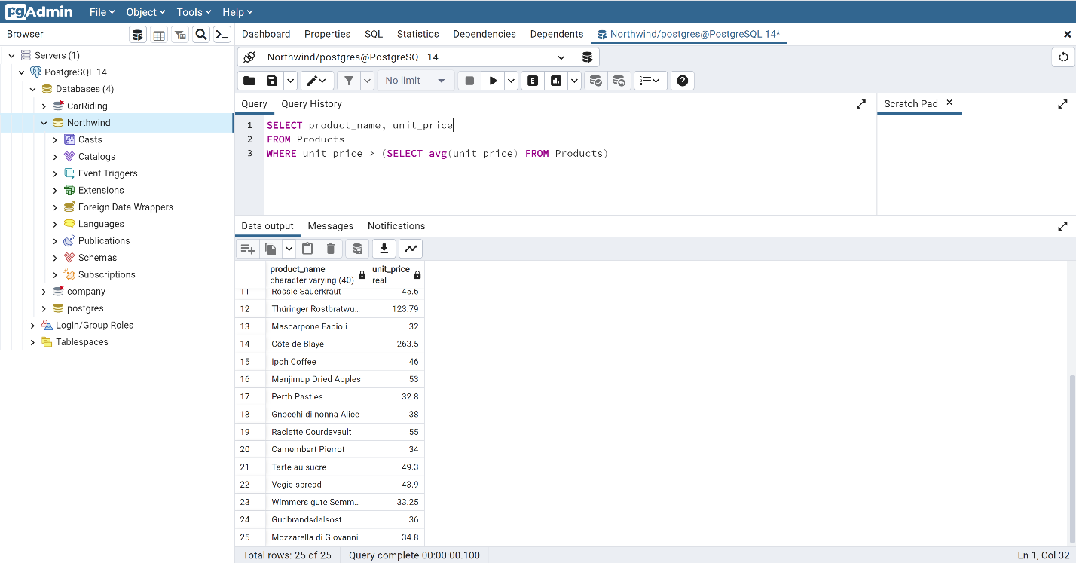

7. Create a report showing the title of courtesy and the first and last name of all employees whose title of courtesy is not "Ms." or "Mrs.".

SELECT title_of_courtesy , first_name , last_name

FROM employees

WHERE title_of_courtesy != 'Ms.'

AND title_of_courtesy != 'Mrs.'

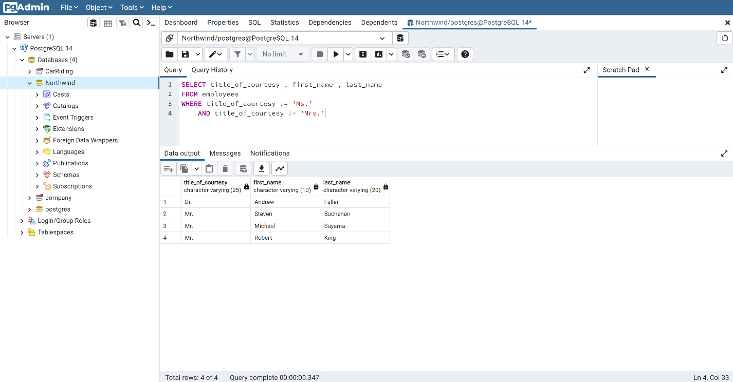

8. Create a report showing the Order ID, the name of the company that placed the order,and the first and last name of the associated employee. Only show orders placed after January 1, 1998 that shipped after they were required. Sort by Company Name.

SELECT order_id, company_name, first_name, last_name,shipped_date, required_date

FROM orders

LEFT JOIN employees on employees.employee_id = orders.employee_id

LEFT JOIN customers on customers.customer_id = orders.customer_id

WHERE order_date > (

SELECT required_date

FROM orders

WHERE required_date = '1998-01-01')

AND shipped_date > required_date

ORDER BY company_name

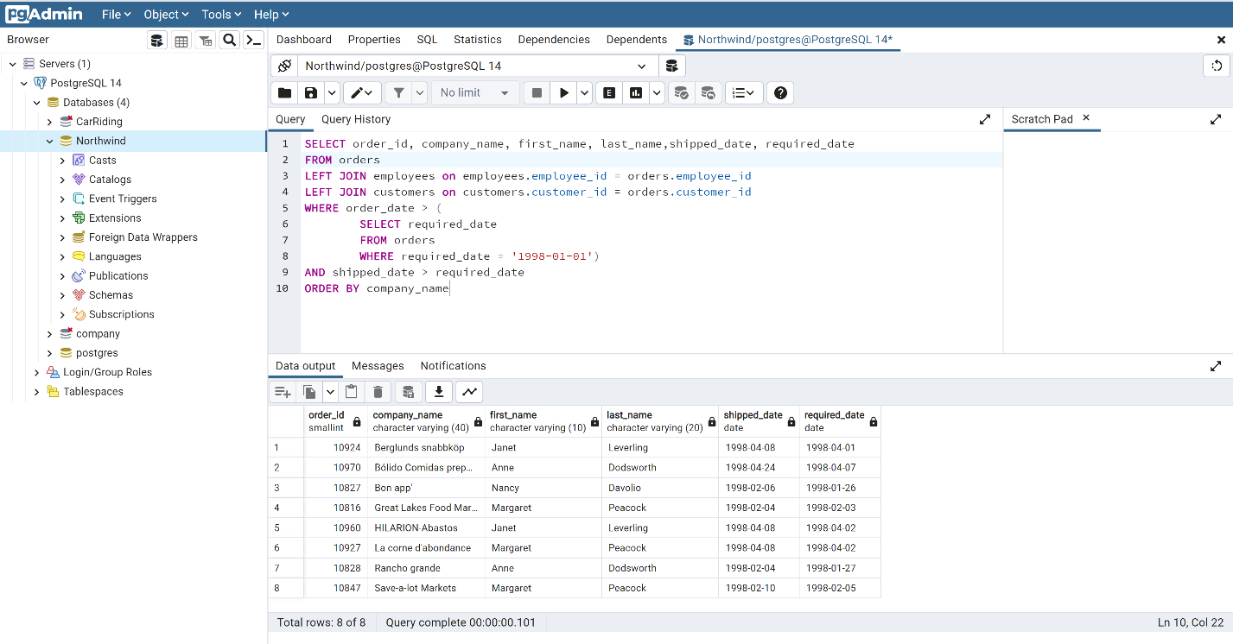

9. Create a report showing the customer ID and company name, employee id, firstname and lastname, and the order id and a conditional column called "Shipped" that displays "On Time" if the order was shipped on time and "Late" if the order was shipped late.

SELECT C.customer_id, C.company_name, E.employee_id, E.first_name,

E.last_name, orders.order_id, orders.required_date, orders.shipped_date,

CASE

WHEN shipped_date > required_date THEN 'Late'

WHEN shipped_date < required_date THEN 'On time'

END AS shipped

FROM orders

JOIN employees as E on E.employee_id = orders.employee_id

JOIN customers as C on C.customer_id = orders.customer_id

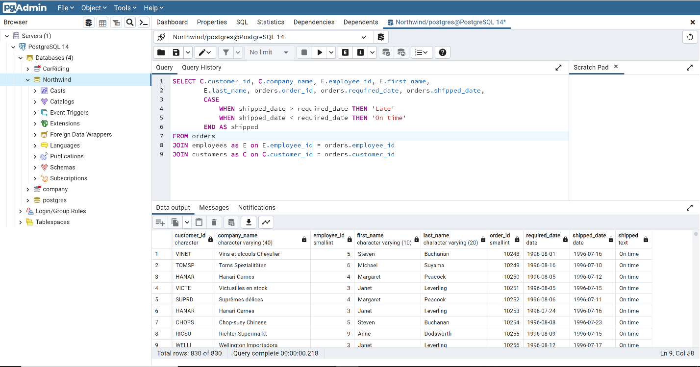

10. Raise the unit price of all products in the Products table by 10% for all products that are out of stock. This should affect 5 rows.

SELECT unit_price + (unit_price *.10) as out_of_stock

FROM products

WHERE units_in_stock = 0

